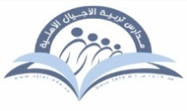
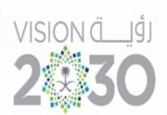

Kingdom of Saudi Arabia Tarbeat Al –Ajial International Schools
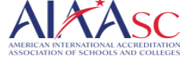
Ministry of Education American Section
Hafr Al Baten Directorate
2024/2025

Student’s name |  | Grade | 1
Subject | Computer | Week No. | 4
Lesson Title | Need of Computer | 1st Semester Work sheet No. | 3
Instruction: Write the correct name of the following devices.

- 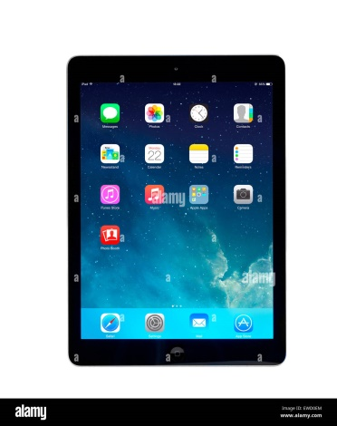 b. 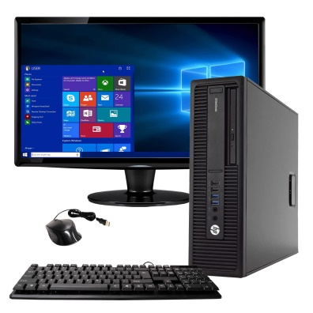
__________________ _________________

c.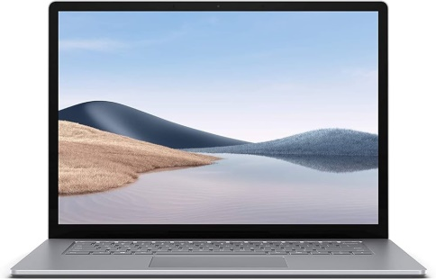 d. 

 

